**Stripe**

**Added 11.07.2017.**

Steps.

**Step 1:**

Go to <https://dashboard.stripe.com/account/apikeys>.

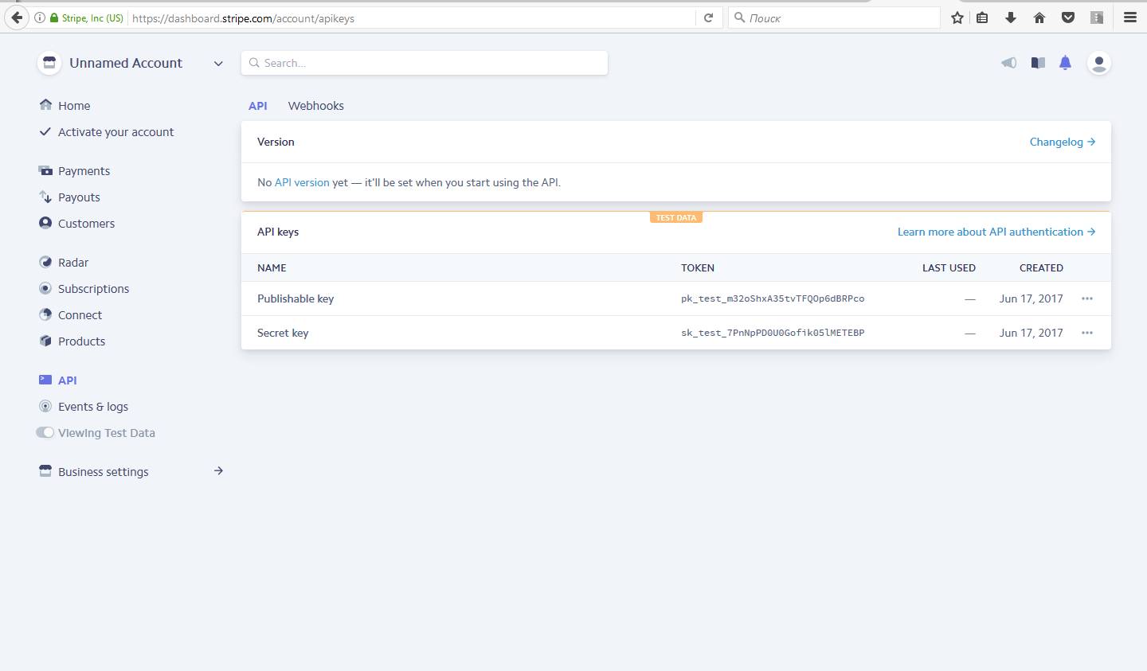

**Step 2:**

Click “Reveal test key token” and get Api Secret test key.

<https://dashboard.stripe.com/account/apikeys>

**Step 3:**

Fill out all requested fields with verified information at

Dashboard -> Activate Your Account.

<https://dashboard.stripe.com/account/details>

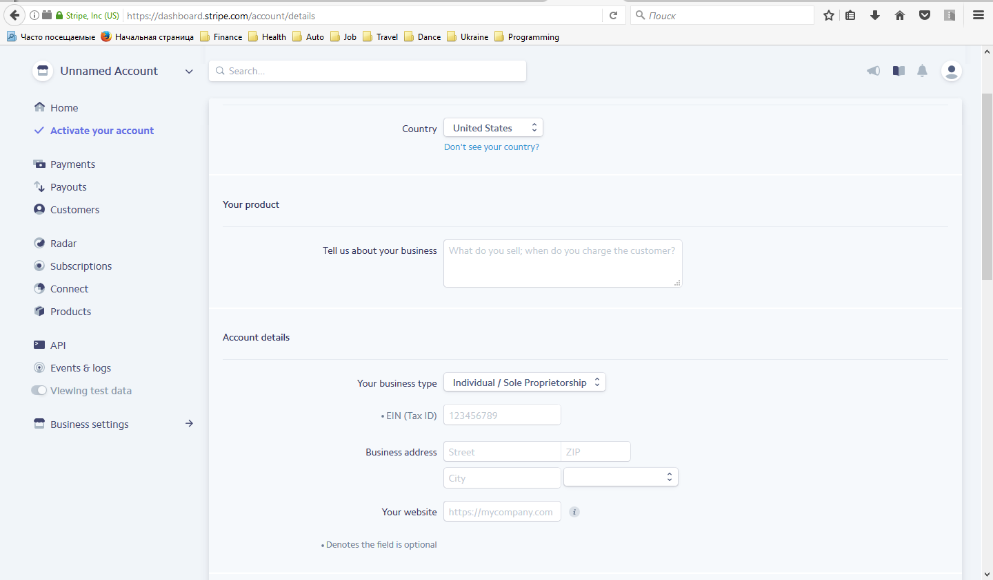

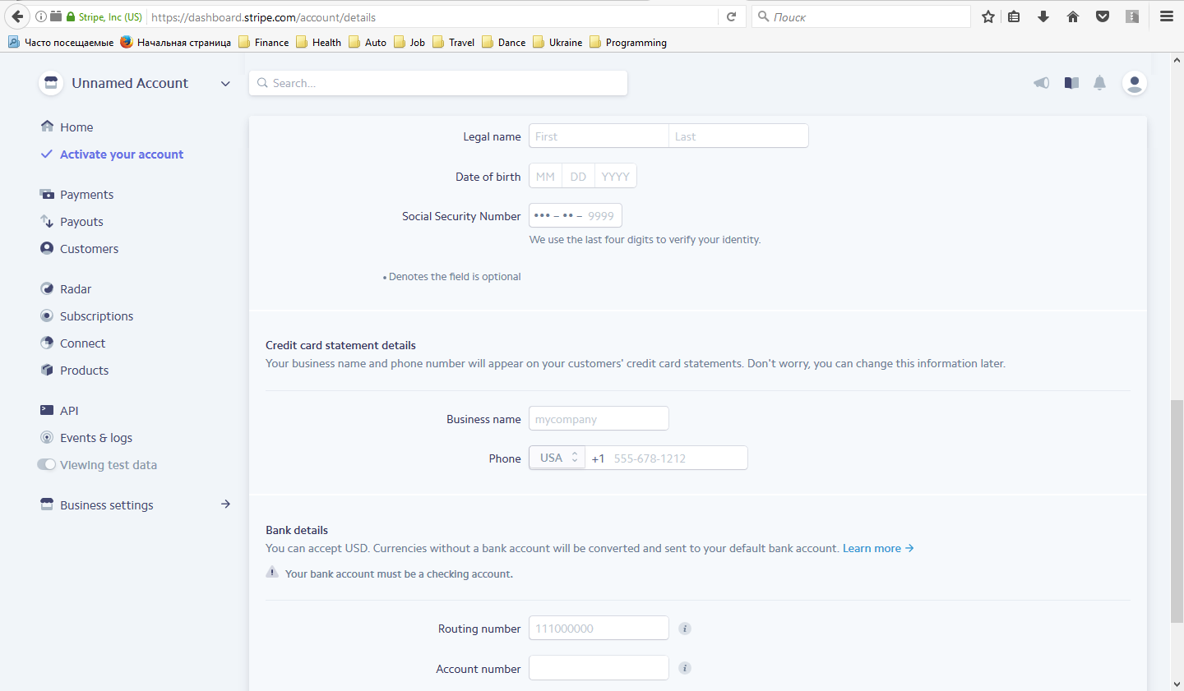

**Step 4:**

Go to <https://dashboard.stripe.com/account/apikeys>

and after that switch to Live Api keys with Viewing Test Data.

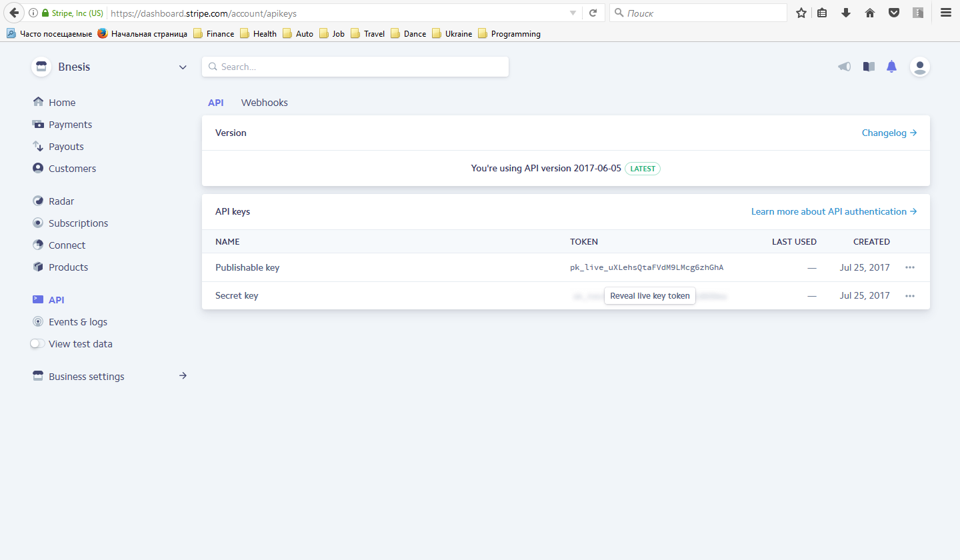

**Step 5:**

Click “Reveal live key token” and get Secret Api live key.

<https://dashboard.stripe.com/account/apikeys>

